**Q1: List all details of customer Anil?**

select c.cname,c.city,b.loanno,b.bname as borrow_branch,sum(b.amount) as borrow_amount,d.actno as deposit_accountno,d.bname as deposit_branch,sum(d.amount) as deposit_amount

from cust c,borrow b,deposit d

where c.cname=b.cname and

c.cname = d.cname

group by c.cname,c.city,b.loanno,b.bname,d.actno,d.bname

having c.cname='ANIL';

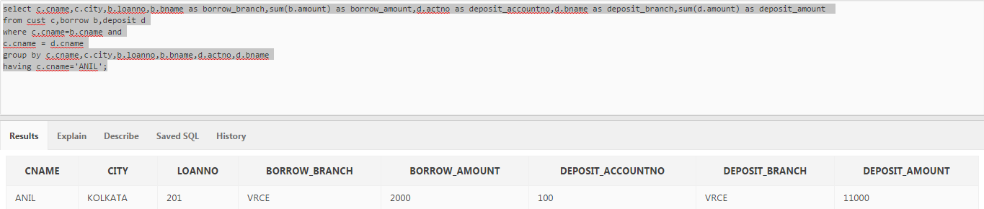

**Q2: List name of Customers having living city Mumbai and Branch city Delhi?**

select cname,living_city,bank_branch from

(select c.cname,c.city as living_city,d.bname as bank_branch from deposit d,cust c

where c.cname = d.cname

and c.city = 'MUMBAI') a,branch b

where a.bank_branch=b.bname

and bank_branch in (select bname from branch where city = 'DELHI');

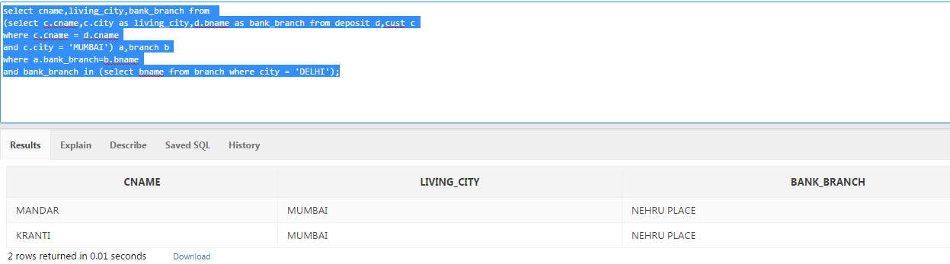

**Q3: List name of Customers having same living city as their Branch city?**

select distinct cname,living_city,b.city as bank_branch_city from

(select c.cname,c.city as living_city,d.bname as bank_branch from deposit d,cust c

where c.cname = d.cname) a,branch b

where a.bank_branch=b.bname

and a.living_city = b.city

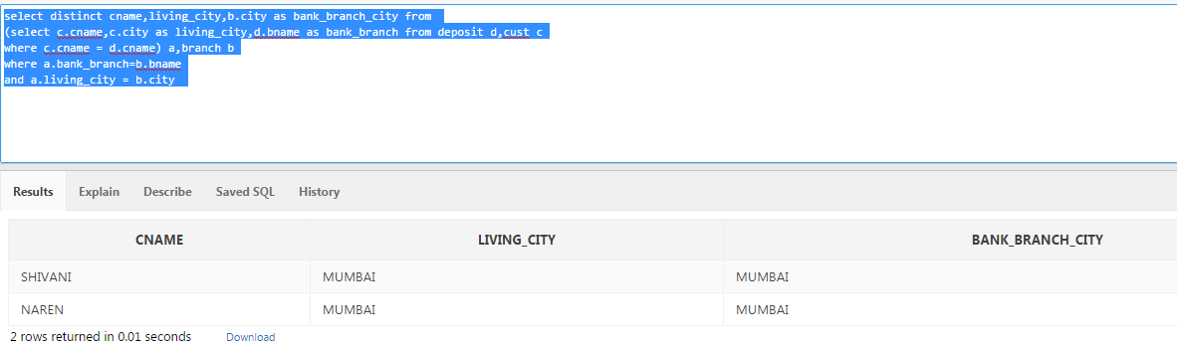

**Q4: List name of Customers who are Borrowers as well as Depostors and having living city Nagpur?**

select a.cname,a.actno,b.loanno from

(select c.cname,c.city as living_city,d.actno from deposit d,cust c

where c.cname = d.cname

and c.city = 'NAGPUR') a, borrow b

where a.cname = b.cname;

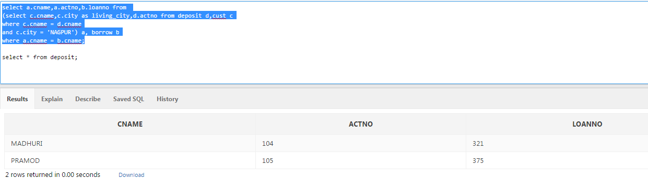

**Q5: List name of Customer who are depositors and have same Branch city as that of Sunil?**

with branch_name as

(select cname,bname from deposit where cname = 'SUNIL')

select distinct d.cname,b.city from deposit d,branch b

where d.bname=b.bname

and b.city = (select city from branch b1,branch_name bn where b1.bname=bn.bname)

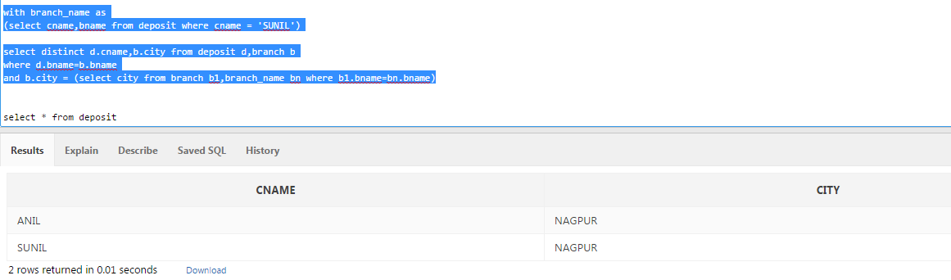

**Q6: List name of Depositors having same living city as that of Shivani and having Deposit amount > 2000?**

with branch_name as

(select cname,city from cust where cname = 'SHIVANI')

select distinct d.cname,b.bname from deposit d,branch b

where d.bname=b.bname

and d.bname in (select b1.bname from branch b1,branch_name bn where b1.city=bn.city)

and d.amount > 2000;

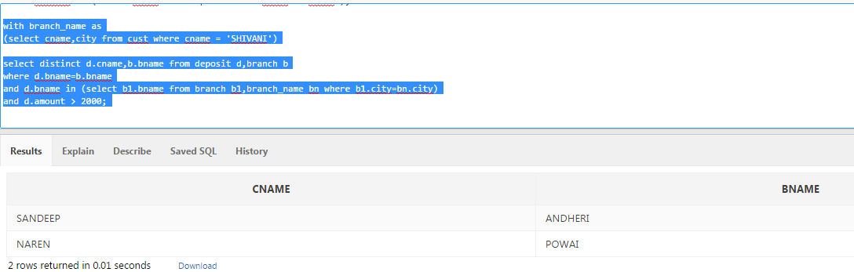

**Q7: List names of borrowers having deposit amount > 1000 and loan amount > 2000?**

select borr.cname,sum(borr.amount) as borrow_amt,sum(d.amount) as deposit_amt

from borrow borr,deposit d

where borr.cname = d.cname

and borr.amount>2000

and d.amount>1000

group by borr.cname

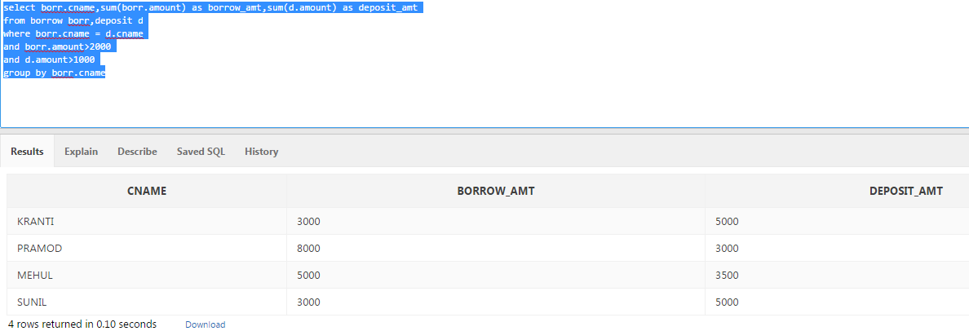

**Q8: List name of Depositors having the same Branch as that of Sunil?**

select cname,bname from deposit

where bname = (select bname from deposit where cname = 'SUNIL')

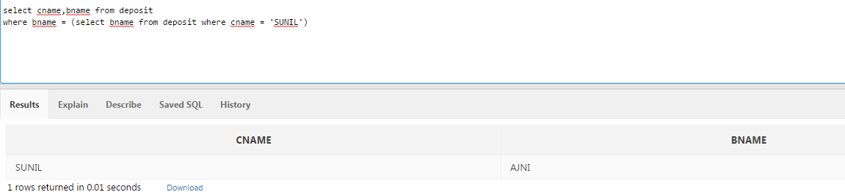

**Q9: List name of borrowers having locan amount > loan amount of Anil?**

select borr.cname,borr.amount from borrow borr

where borr.amount > (select amount from borrow where cname = 'ANIL')

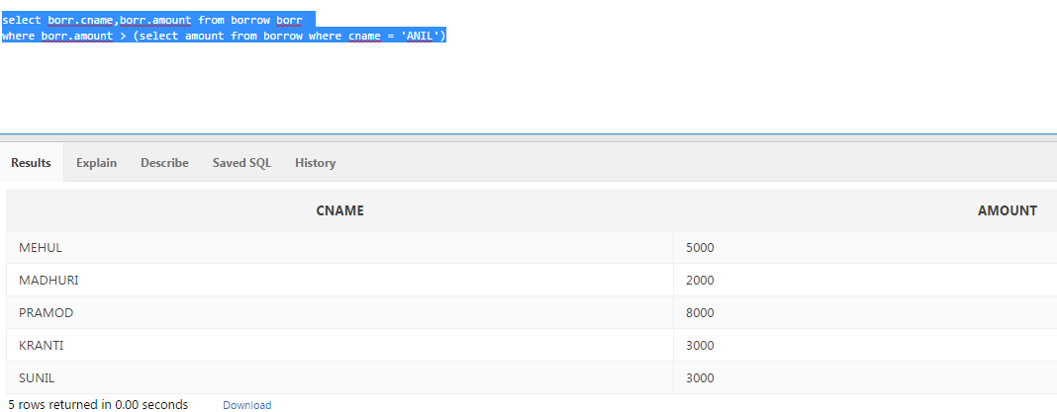

**Q10: List name of Customers living in the City where branch of Depositor Sunil is located?**

with branch_name as

(select cname,bname from deposit where cname = 'SUNIL')

select distinct c.cname,b.city from cust c,branch b

where c.city=b.city

and c.city = (select city from branch b1,branch_name bn where b1.bname=bn.bname)

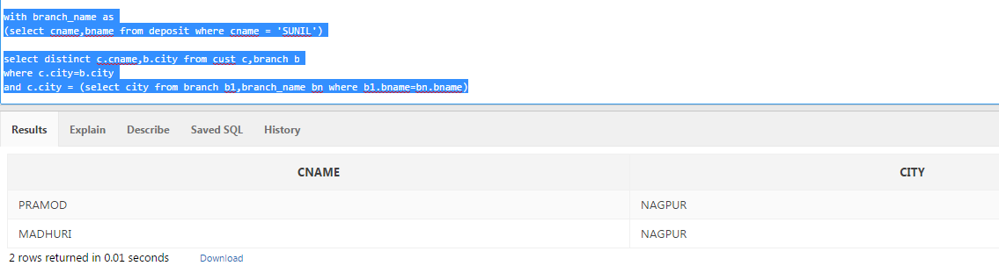

**Q11: List Loan Number and Loan Amount of borrowers having the same Branch as that of Depositor Sunil?**

select distinct borr.cname,borr.loanno,borr.amount from borrow borr,branch b

where borr.bname=b.bname

and borr.bname = (select bname from deposit where cname = 'SUNIL')

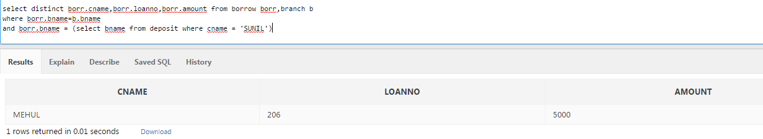

**--Q12: List Loan Number, Loan Amount, Account Number and Deposit Amount of Customers living in Nagpur?**

with customer_name as

(select cname from cust where city = 'NAGPUR')

SELECT cname,loanno,borrow_branch,sum(borrow_amt) as borrow_amount,deposit_actno,deposit_branch,sum(deposit_amt) as deposit_amount

FROM (

select br.cname,br.loanno,br.bname as borrow_branch,sum(br.amount) as borrow_amt,NULL deposit_actno,NULL deposit_branch,NULL deposit_amt

from borrow br,customer_name bn

where br.cname=bn.cname

group by br.cname,br.loanno,br.bname

union all

select d.cname,NULL loanno,NULL borrow_branch,NULL borrow_amt,d.actno as deposit_actno,d.bname as deposit_branch,sum(d.amount) as deposit_amt

from deposit d,customer_name bn1

where d.cname=bn1.cname

group by d.cname,d.actno,d.bname) JOIN_DEP_BORR

group by cname,loanno,borrow_branch,deposit_actno,deposit_branch;

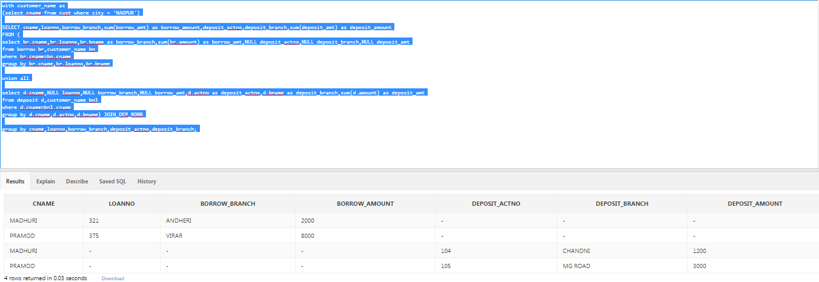

*************

select A.cname,A.loanno,A.borrow_amt,B.deposit_actno,B.deposit_amt from

(select br.cname,br.loanno,sum(br.amount) as borrow_amt,NULL deposit_actno,NULL deposit_amt

from borrow br

where br.cname in (select cname from cust where city = 'NAGPUR')

group by br.cname,br.loanno,br.bname) A,

(select d.cname,NULL loanno,NULL borrow_amt,d.actno as deposit_actno,sum(d.amount) as deposit_amt

from deposit d

where d.cname in (select cname from cust where city = 'NAGPUR')

group by d.cname,d.actno, d.bname) B

where a. cname = b.cname;

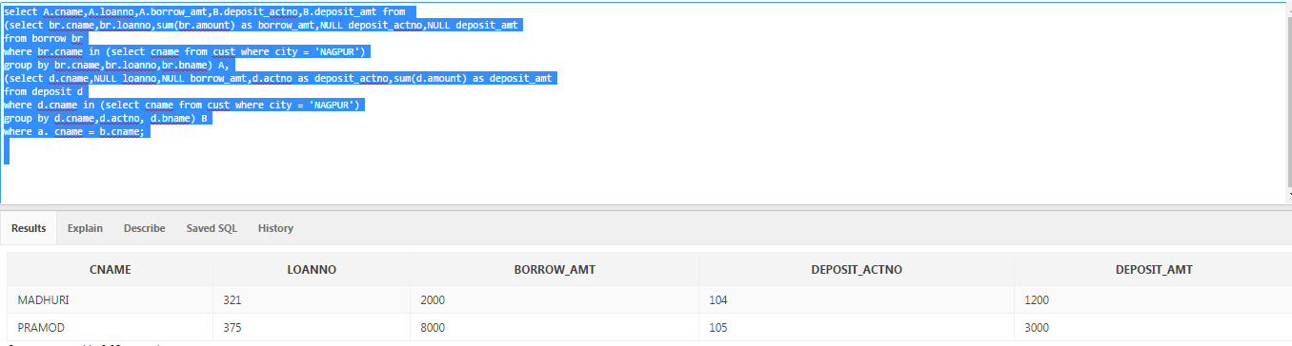

SELECT DISTINCT A.cname,A.loanno,A.borrow_branch,sum(A.borrow_amt) as borrow_amount,B.deposit_actno,B.deposit_branch,sum(B.deposit_amt) as deposit_amount

FROM

(select br.cname,br.loanno,br.bname as borrow_branch,sum(br.amount) as borrow_amt,NULL deposit_actno,NULL deposit_branch,NULL deposit_amt

from borrow br

where br.cname in (select cname from cust where city = 'NAGPUR')

group by br.cname,br.loanno,br.bname) A,

(select d.cname,NULL loanno,NULL borrow_branch,NULL borrow_amt,d.actno as deposit_actno,d.bname as deposit_branch,sum(d.amount) as deposit_amt

from deposit d

where d.cname in (select cname from cust where city = 'NAGPUR')

group by d.cname,d.actno,d.bname) B

group by A.cname,A.loanno,A.borrow_branch,B.deposit_actno,B.deposit_branch;

**Q13: List Loan Number, Loan Amount, Account Number and Deposit Amount of Customers having Deposit Branch in Delhi?**

with branch_name as

(select bname from branch where city = 'DELHI')

SELECT cname,loanno,borrow_branch,sum(borrow_amt) as borrow_amount,deposit_actno,deposit_branch,sum(deposit_amt) as deposit_amount

FROM (

select br.cname,br.loanno,br.bname as borrow_branch,sum(br.amount) as borrow_amt,NULL deposit_actno,NULL deposit_branch,NULL deposit_amt

from borrow br,branch_name bn

where br.bname=bn.bname

group by br.cname,br.loanno,br.bname

union all

select d.cname,NULL loanno,NULL borrow_branch,NULL borrow_amt,d.actno as deposit_actno,d.bname as deposit_branch,sum(d.amount) as deposit_amt

from deposit d,branch_name bn1

where d.bname=bn1.bname

group by d.cname,d.actno,d.bname) JOIN_DEP_BORR,branch_name bn2

where bn2.bname = JOIN_DEP_BORR.borrow_branch or

bn2.bname = JOIN_DEP_BORR.deposit_branch

group by cname,loanno,borrow_branch,deposit_actno,deposit_branch;

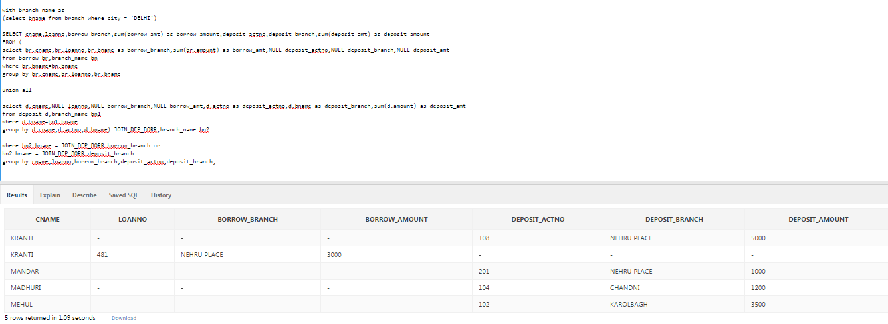

**Q14: List Loan Number, Loan Amount, Account Number, Deposit Amount, Branch Name, Branch City and Living City of Pramod?**

select distinct A.cname,A.loanno,A.borrow_branch,A.borrow_amt,B.deposit_actno,B.deposit_branch,B.deposit_amt,C.city as Living_city

from

(select br.cname,br.loanno,br.bname as borrow_branch,sum(br.amount) as borrow_amt

from borrow br

where br.cname='PRAMOD'

group by br.cname,br.loanno,br.bname) A,

(select d.cname,d.actno as deposit_actno,d.bname as deposit_branch,sum(d.amount) as deposit_amt

from deposit d

where d.cname='PRAMOD'

group by d.cname,d.actno, d.bname) B,

cust c

where c.city = (select city from cust where cname = 'PRAMOD')

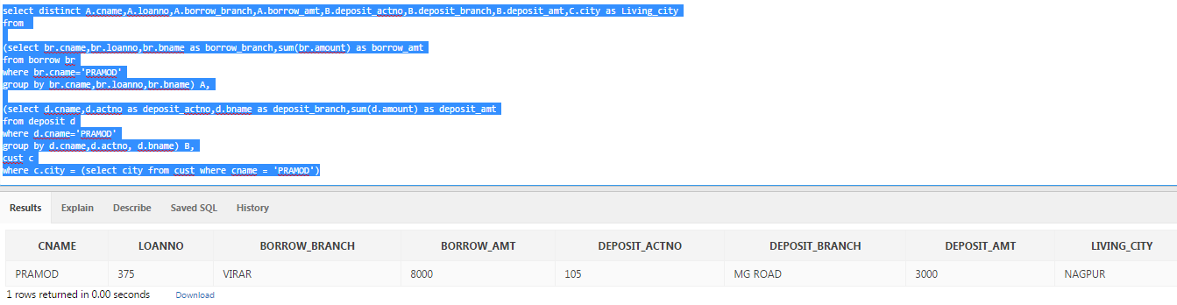

**Q15: List Deposit Details and Loan Details of Customer in the City where Pramod is living?**

select br.cname,br.loanno,br.bname as borrow_branch,sum(br.amount) as borrow_amt,NULL deposit_actno,NULL deposit_branch,NULL deposit_amt

from borrow br

where br.bname in (select bname from branch where city= (select city from cust where cname = 'PRAMOD'))

group by br.cname,br.loanno,br.bname

union all

select d.cname,NULL loanno,NULL borrow_branch,NULL borrow_amt,d.actno as deposit_actno,d.bname as deposit_branch,sum(d.amount) as deposit_amt

from deposit d

where d.bname in (select bname from branch where city= (select city from cust where cname = 'PRAMOD'))

group by d.cname,d.actno,d.bname

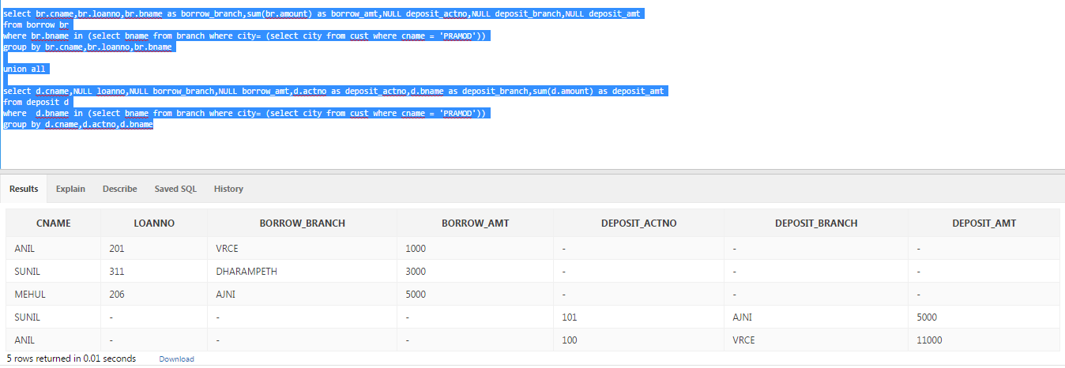

**Q16: List names of Depositor having the same Branch city as that of Sunil and having the same Living city as that of Anil?**

select A.cname,A.bname,B.city from

(select distinct cname,bname from deposit where bname in (select bname from branch where city = (select city from branch where bname = (select bname from deposit where cname = 'SUNIL'))) ) A, cust b

where A.cname=B.cname and

B.city = (select city from cust where cname = 'ANIL')

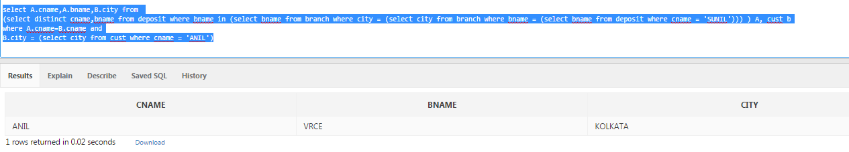

**Q17: List names of Depositors having amount > 1000 and having the same living city as Pramod?**

select A.cname,A.dep_amt,B.city as Living_City from (select cname,sum(Amount) as dep_amt from deposit where amount> 1000 group by cname) A, cust B

where A.cname=B.cname

and B.city = (select City from cust where cname = 'PRAMOD')

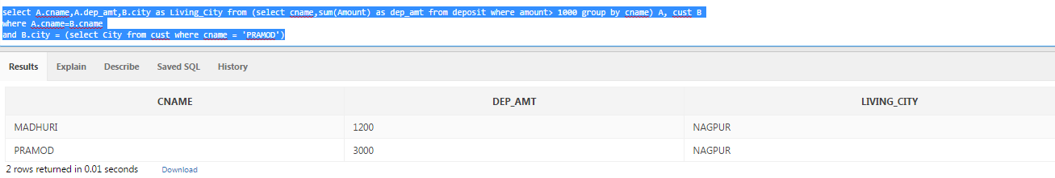

**\*Q18: List city of Customer having the same branch city as that of Pramod?**

select cname,city as Living_city from cust where city = (select city from branch where bname = (select bname from borrow where cname = 'PRAMOD')) OR

city = (select distinct city from branch where bname = (select bname from deposit where cname = 'PRAMOD'))

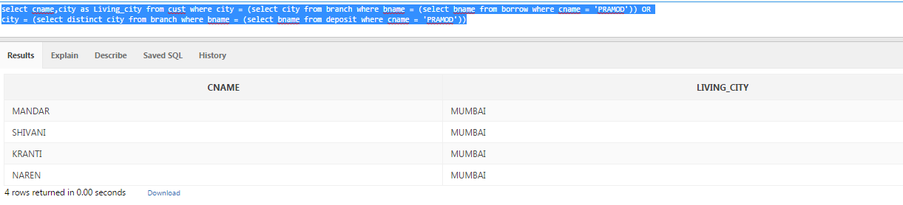

**Q19: List the Branch city and Living city of Pramod?**

select C.cname,A.bname as Borrow_branch,B.bname as Deposit_branch,c.city as living_city from

(select bname from borrow where cname= 'PRAMOD') A,

(select bname from deposit where cname = 'PRAMOD') B,

cust C

where c.cname='PRAMOD'

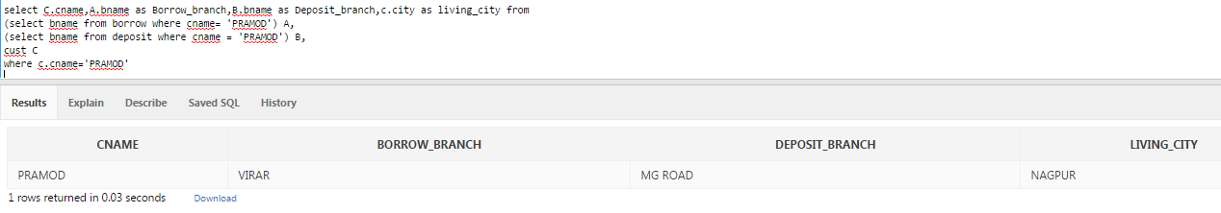

**Q20: List the Branch city of Sunil or Branch city of Anil?**

select distinct C.cname,A.bname as Borrow_branch,B.bname as Deposit_branch from

(select cname,bname from borrow where cname= 'PRAMOD' union select cname,bname from borrow where cname= 'ANIL') A,

(select cname,bname from deposit where cname = 'PRAMOD' union select cname,bname from borrow where cname= 'ANIL') B,

cust C

where a.cname=b.cname

and b.cname=c.cname;

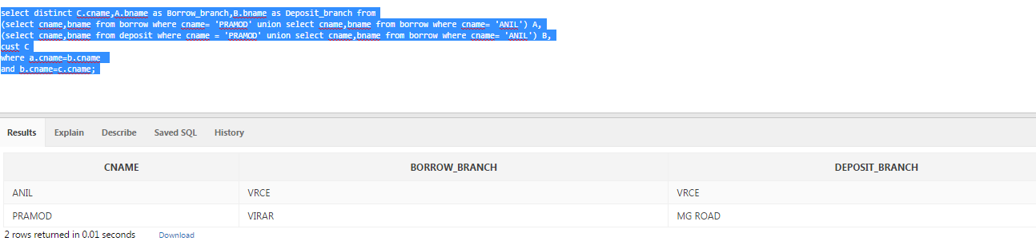

**Q21: List the Living city of Anil or Living city of Sunil?**

select cname,city from cust where cname='ANIL' or cname = 'SUNIL';

